**Preliminary 25 examination questions** (*Computer Programming, Fall 2024*)

1. Write C++ program that prints hello world message.

2. Write C++ program that performs addition.

3. Write C++ program that creates variables with different data types.

4. Write C++ program that prints several string text and some in new line.

5. Write C++ program that compares two variables with each other.

6. Write C++ program that finds out if two variable values are same or not same by comparing.

7. Write C++ program that finds out if two variable values are same or not same by comparing using ternary operator.

8. Write C++ program that uses while loop to increment value of local variable.

9. Write C++ program that uses do while loop to increment value of local variable.

10. Write C++ program to demonstration increment operation with post and pre options.

11. Write C++ program to demonstration decrement operation with post and pre options.

12. Find Syntax errors from the following code snippet.

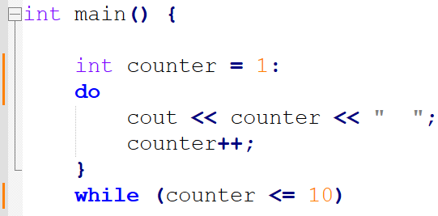

13. Find Syntax errors from the following code snippet.

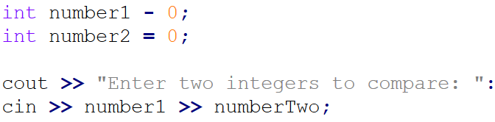

14. Find Logic errors from the following code snippet.

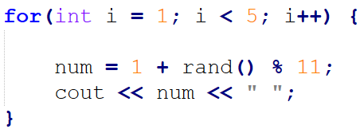

15. Write complete C++ program that takes two input and performs addition and subtraction.

16. Write complete C++ program that takes two input and performs multiplication and division.

17. Write complete C++ program that demonstrates use of modulus (%) operator.

18. Write C++ code snippet for integer array with four values.

19. Write C++ code snippet for floating point array with four values.

20. Write C++ code snippet that uses array in for loop.

21. Explain the purpose of variable in computer program.

22. What is function in computer programming.

23. What is considered as Syntax error in computer programming.

24. What is considered as Logic and runtime error in computer programming.

25. What are the common steps of creating the computer program. How C++ program creation is different from Java and PHP program build.

~ ~ END OF DOCUMENT ~~